Name:_________________________________ Class:__________________________________

**Start Date: Sunday, February 21, 2016** **Due Date: Monday, April 18, 2016**

For this activity you will make a drawing of the phase of the Moon on the worksheet(s) provided. Now this is going to take some patience because you can only make one drawing per day. Sometimes the Moon will be in the west. Other times it will be in the east. So, you have to look around. Draw as many pictures as you can during the month. At the end of the month draw in the missing phases with what you think they should be. Be sure to write down the date (not day) and time of your observation. On the back of this sheet you will log other obervations like what kind of weather conditions you had each night. You will also right down your location. Try to make you observations from the same location each night if possible.

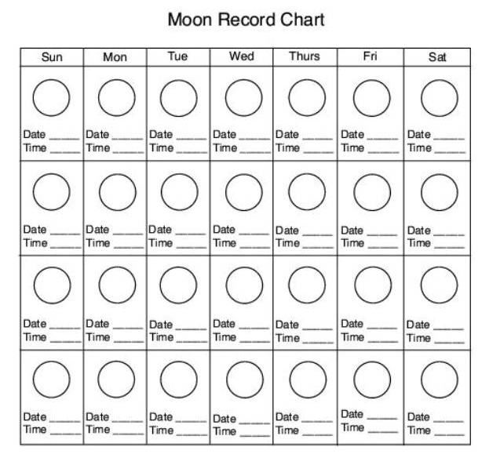

|  |  |  |
| --- | --- | --- |
| **Date** | **Location** | **Weather Conditions** |
|  |  |  |
|  |  |  |
|  |  |  |
|  |  |  |
|  |  |  |
|  |  |  |
|  |  |  |
|  |  |  |
|  |  |  |
|  |  |  |
|  |  |  |
|  |  |  |
|  |  |  |
|  |  |  |
|  |  |  |
|  |  |  |
|  |  |  |
|  |  |  |
|  |  |  |
|  |  |  |
|  |  |  |
|  |  |  |
|  |  |  |
|  |  |  |
|  |  |  |
|  |  |  |
|  |  |  |
|  |  |  |
|  |  |  |
|  |  |  |